COS20019
Cloud Computing Architechture
Truong Ngoc Gia Hieu
105565520
Challenge (Cafe) lab: Migrating a Database to Amazon RDS

A. Scenario

The café currently uses a single Amazon Elastic Compute Cloud (Amazon EC2) instance to host its web server, database, and application code.

Meanwhile, the café business has grown. The order history that is stored in the database provides valuable business information that the café staff doesn't want to lose. Martha uses the data for accounting, and Frank looks at it occasionally to plan how many of each dessert type he should bake.

Sofía has additional concerns. The database must be consistently upgraded and patched, and she doesn’t always have time to do these tasks. Also, administering the database is a specialized skill. Training others to do database administration isn’t something that she wants to spend time on. Meanwhile, Sofía is also concerned that the café isn’t doing data backups as often as they should.

Finally, Martha also wants to reduce labor costs that are associated with the technical learning investment that's needed to manage the database.

B. Lab overview and objectives

In this lab, you migrate data from a database on an EC2 instance to Amazon Relational Database Service (Amazon RDS). Specifically, you migrate a MariaDB database that runs on an EC2 instance to a MariaDB database that runs on Amazon RDS. You also update the café web application to use the new database to store data for all future orders.

After completing this lab, you should be able to do the following:
- Create an RDS database instance.
- Export data from a MariaDB database by using mysqldump.
- Connect a SQL client to an RDS database.
- Migrate data from a MariaDB database that runs on an EC2 instance to an RDS database instance.
- Configure a web application to use the new RDS database instance for data storage.

When you start the lab, the following resources are already created for you in the AWS account:

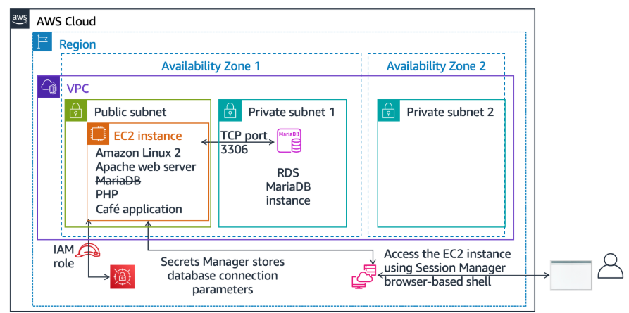
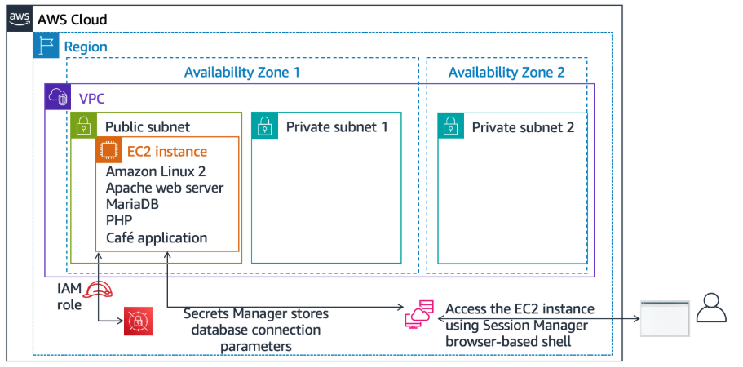
At the end of this lab, your architecture will look like the following example:

Duration
This lab requires approximately 80 minutes to complete.

AWS service restrictions
In this lab environment, access to AWS services and service actions might be restricted to the ones that are needed to complete the lab instructions. You might encounter errors if you attempt to access other services or perform actions beyond the ones that are described in this lab.

C. Accessing the AWS Management Console
To access the AWS Management Console, click on the button Start Lab and wait until the circle turns from red to green

A business request: Creating an RDS instance for the café application (challenge 1)

After a conversation with Olivia—the AWS solutions architect who often comes in for coffee—Sofía decided that the café needs a database solution that is easier to maintain. In addition, the database should provide essential features such as durability, scalability, and high performance.

In the first part of this lab, you take on the role of Sofía. You create an RDS instance that the café can use as the data storage layer for the café website. You also connect to the EC2 instance and analyze the details of the cafe web application.

D. Task 1: Creating an RDS instance
Step 1.1: Go to the Amazon RDS console, and create an RDS instance with the following specifications.
When you submit your work at the end of this lab, it will check for many of these settings. To get full credit, follow these guidelines.

Step 1.2: In the Engine options section, for Engine type, choose MariaDB.

Step 1.3: For Templates, choose Dev/Test

Step 1.4: In the Settings section, configure the following options:
- DB instance identifier: Enter CafeDatabase.
- Master username: Enter admin.
- Master password and Confirm master password: Enter Caf3DbPassw0rd!.
- You must use this precise password.
- Tip: Copy and paste the password to set it.

Step 1.5: In the Instance configuration section, for DB instance class, choose Burstable classes (includes t classes), and then choose db.t3.micro.

Step 1.6: In the Storage section, configure the following options:
- Storage type: Choose General Purpose SSD(gp2).
- Allocated storage: Enter 20 GiB.

